Farly Chan Magbanua Jr
(Sean Philip Chan / 陈祥恩)
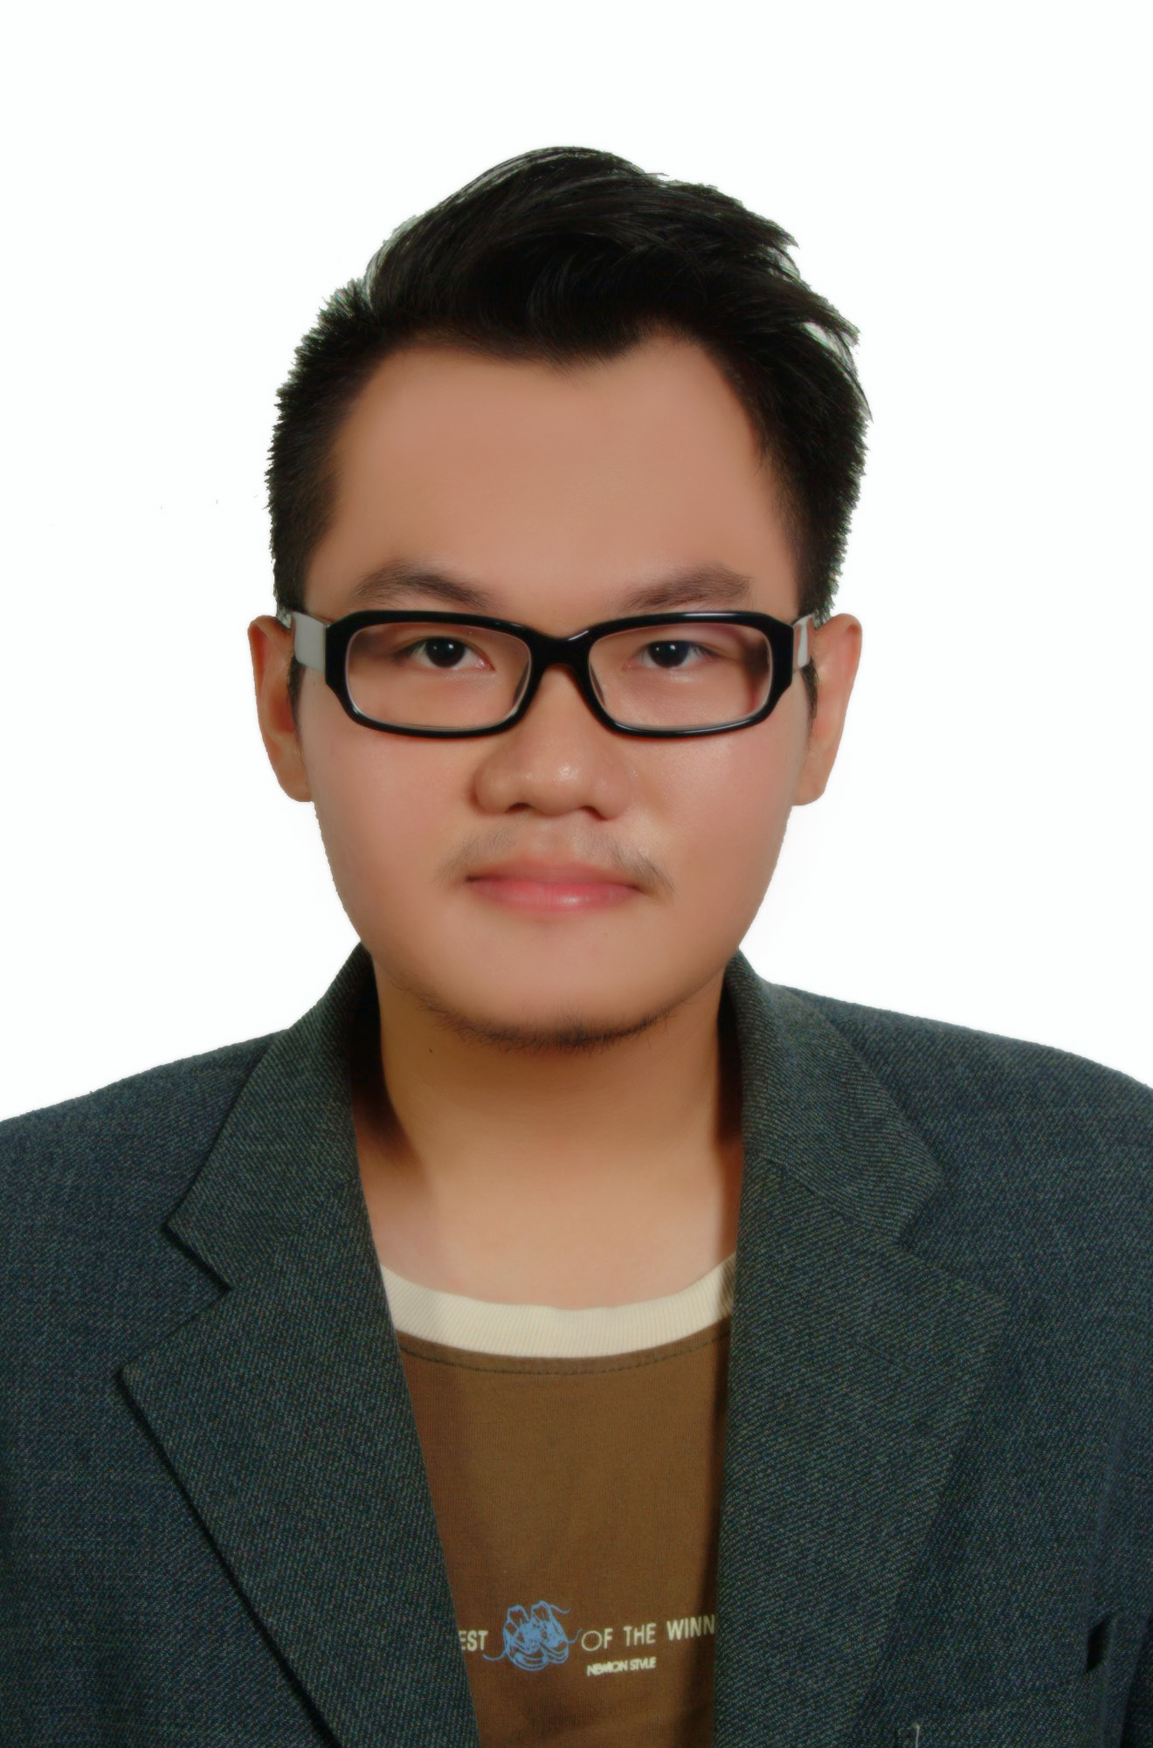
Contact Details

Address 1 : BRANDYWELL, 174 EDGEWOOD LAWNS, BLANCHARDSTOWN, D15 X4PY DUBLIN 15, IRELAND.

Address 2 : Utterstigen 9, Enhörna, Södertälje, 15150 Sweden

Mobile No. : +353 (89) 2584096 (Irish Mobile Number)
Swedish Contact: Mobile: +46 73977 4816 / Home: +46 8 550 44624
Email : seanphilip.chan@gmail.com

Personal Particulars

Date of Birth : 26 May 1991
Nationality : Malaysia Permanent Resident (PR) / Origin: Philippines
Gender : Male
Religion : Roman Catholic
Marital Status : Single
Malaysia IC No. : 910526-65-5013
Passport No. : P3690209A

Others

• Irish GNIB No.: 767993
• Irish PPS No: 1920194PA

Educational Background

SJK© Peng Bin (1998-2003) | UPSR  - Primary School Certification
SMK Berapit (2004-2009) | PMR,SPM  - High School Certification of Malaysia
Han Chiang College (2011-2013) | Diploma In Information Technologies
Institute of Technology Blanchardstown ITB (2016 to Present) | Degree of Bachelor of Science in Computing

Courses Studied in Han Chiang College (Year 2011 - 2013)

- Computer Application Software
- Computer Programming I
- Mathematics
- Computers & Computing
- Computer Organization & Architecture
- Mathematics for Information Technology
- Computer Programming II
- Communication Systems & Networks
- Database Management Systems
- C++ Programming
- The Fundamentals of Electronic Commerce
- Applications Development with Visual Basic
- Systems Analysis & Design
- Multimedia Technology & Management
- Multimedia Web Authoring
- Object-oriented Programming with JAVA
- Operating Systems
- Malaysian Studies
- Moral Education
- Bahasa Malaysia
- Spoken English I
- Communicate English
- Algorithms and Data Structures
- Probability and Statistics
- Systems Development Project
- Industrial Training
- Spoken English II
- Basic Writing and Study Skills
- Information Systems Project Management
- Information Security and Assurance
- English for IT and Multimedia
- Human Computer Interaction

Modules Studied in Institute Technology of Blanchardstown (Year 2016 – 2018)
- Object Orientation with Design Patterns
- Rich Web Application
- Data Structures and Algorithms
- Advanced Switching and Routing
- Project Skills
- Network Distributed Systems
- Troubleshooting IP Networks
- Parallel Computing
- Web Framework Development

Computer and other additional skills (Mainly from Previous Work Experience)
- Networking skills
- Computer Architecture
- Used Flash 8 to create animation work while studying in Han Chiang College
- Microsoft word, Excel, Power Point
- System Analysis
- System Support
- Information System Project Management
- Operating System like Window XP, 7, 8, 10 and familiar with using LINUX.
- Computer Security
- Computer troubleshooting Skills
- Hardware troubleshooting skills ( Dot Metric Printer, Intermec Printer, Multifunctional Printer, RF Scanner, 1D Scanner, 2D Scanner and etc.)
- Flex Flow Software – A routing software in Flex and being used by Flex Company around the world.
- Star Software – A software to support the manufacturing of Seagate project.
- Basic software troubleshooting skills
- Power LED – A software to configure the animation output of a LED Board
- Baan Software – A software is being used in Flex’s company especially in the Kitting area and Store.
- Clonezilla
- GParted
- Ghost
- Hirenboot
- MES System – which being used in Flex to support the daily production manufacturing system.
- Programming C language
- Java Programming
- HTML
- CSS
- Typescript
- JSON
- Angular
- Javascript
- XML
- PHP Strom
- Symfony 3
- Symfony 4
- MySQL

Employment History

-System Support (Year 2013)
(Industrial Training – Internship)

-Desksite Support Engineer (Year 2013 - 2016)
- Flextronics Technology (Penang, Malaysia)

Company Name : Flextronics Technology ( Penang )
Job Title : IT Onsite Support
Job Type : Full Time / Permanent
Industry : Manufacturing - Electronics
Duration : October 2013 to August 2016

IT Onsite Support

As an IT Support, my job function included Office and production troubleshooting support - including software and hardware, networking, hardware inventory and 5S Store Room.

Responsibilities :
- Troubleshot hardware, software, and network problems over phone.
- Provided on-site simultaneous support to multiple users in diverse locations.
- Monitored and reported on incoming phone calls, issues, and resolutions.
- Prepared reports for a variety of corporate systems and programs.
- Provided training to users on software and hardware components.
- Administered installation of computers, software and peripherals.
- Support in Flex Flow and STARS routing for all the projects which process during the manufacturing.

Project Handled in Flextronics
Job scopes including support in production process manufacturing, and support in Flex Flow project and Routing:

- Seagate
- Cisco Systems
- Juniper
- Intel
- Dyson
- Honeywell
- Avago
- Tellabs
- Ericsson
- Lenovo

Language Proficiency

Language Spoken Written
Chinese/Mandarin Native Good
Cantonese & other dialects Fluent Average
English Fluent Good
Malay Good Average

Personal quality:

- Excellent experience in IT & computing especially global projects;
- Have a weight and maturity to negotiate with counterpart in all level;
- Result oriented;
- Excellent in fields of communications, PR and good presentation skills;
- Strong ability to impact and influence;
- Excellent leadership capabilities in a team;
- Excellent interpersonal skills and strong achievement drive and persevering
- A good team player.

Able To Start Work
- Immediate, after Offer Letter and process done;
- After completed my study in ITB in August 2017

Achievements (Co-curriculum)
- Student Sport Ireland Badminton League 2017
- Penang Super Run 2016
- Butterworth Run 2016
- MGBC Eco Power Run 2016
- BM Run 2016
- Penang Bridge International Marathon 2008 to 2015- Half Marathon (42km)
- Poetry Recital 2004-Third
- Shaolin Wushu Tournament Seberang Perai 2007 –Yinggong – Gold Medal
i) 2007 –Tuishou – Gold Medal
ii) 2007 – Free sparing – Silver Medal
iii) 2008 – Free sparing – Gold Medal
iv) 2008 –Tuishou – Gold Medal
v) 2009 – Free sparing – Gold Medal
- Tae Kwon Do 2nd Grade Red Belt in year 2003

References:

Mr Sethu Vengadasalam
(IT Manager of Flex- Penang, MALAYSIA)
+6012-4044716

Mr. K Sun Lee
(MES Team Support in Flex – Penang, MALAYSIA)
+60174185095

Michael O’Donnell
(Course coordinator of Computer Science in ITB)
Email: michael.o'donnell@itb.ie

*********** End of Text ***************

